|  |  |
| --- | --- |
| COLLEGE NAME | SARANATHAN COLLEGE OF ENGINEERING |
| TITLE | HOW TO CREATE BRAND NAME, BRAND MAIL AND BRAND LOGO IN CANVA |
| NAME | ROSHNI R |
| NM ID | 1E0C89A485541C38A1C4022FE3BA8DD6 |
| DATE | 27-10-2023 |

BRAND NAME : COOLER SHADES

Linked In :

<https://www.linkedin.com/in/roshni-r-331110269>

FACEBOOK :

<https://www.facebook.com/profile.php?id=61552679826772>

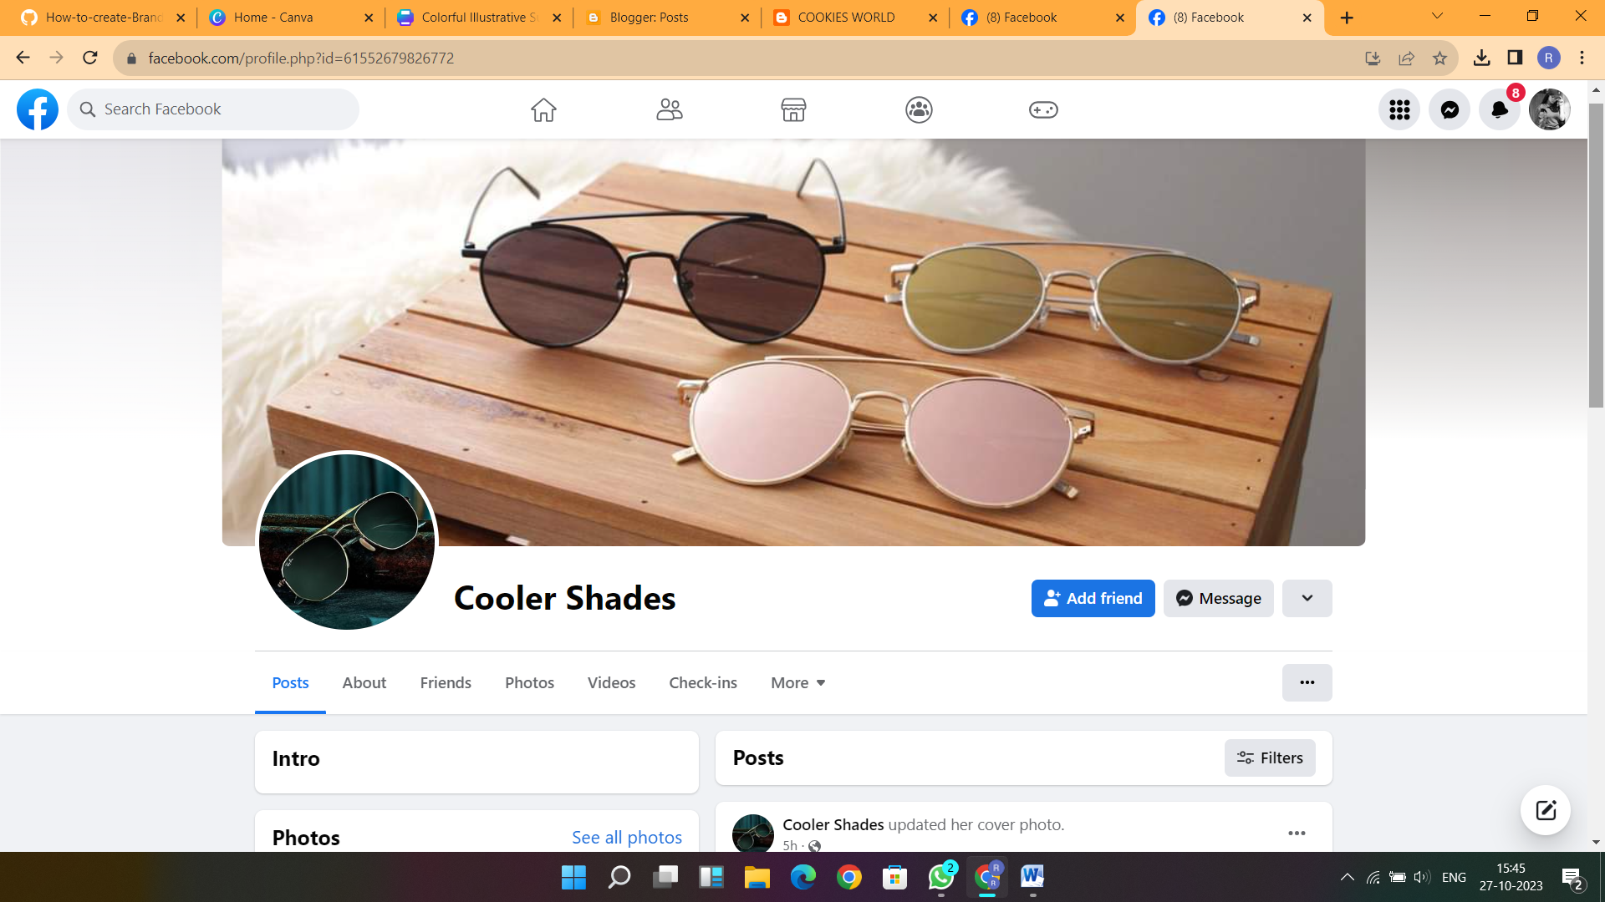

BLOG OR WEBSITE URL :

<https://fashiontraverse.blogspot.com/2023/08/fashionsurveyideas.html>



EMAIL NEWSLETTER :

[https://cookiesworldmagic.blogspot.com/2023/09/blog-post.html](%20%20https:/cookiesworldmagic.blogspot.com/2023/09/blog-post.html)

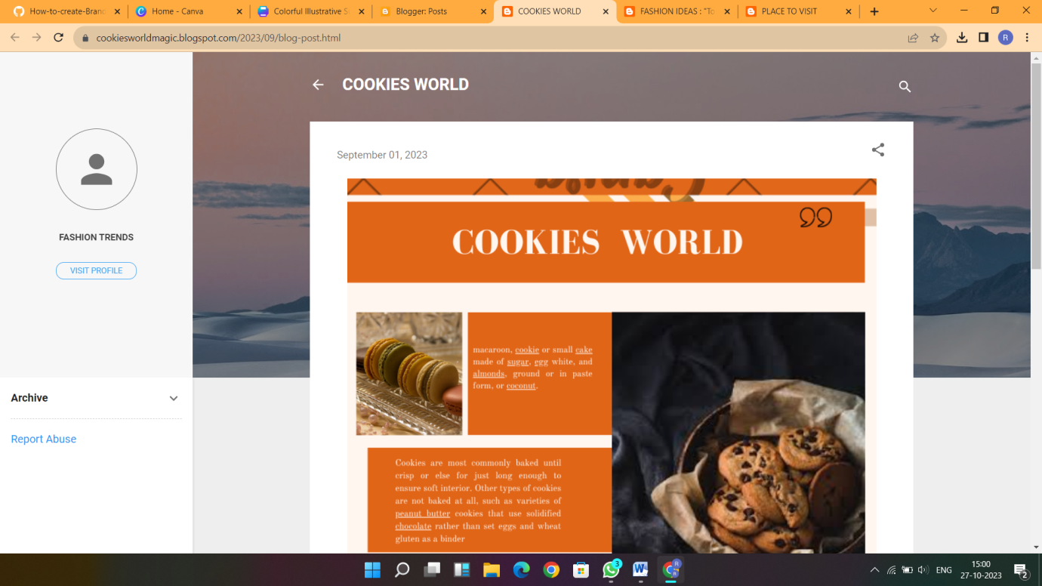

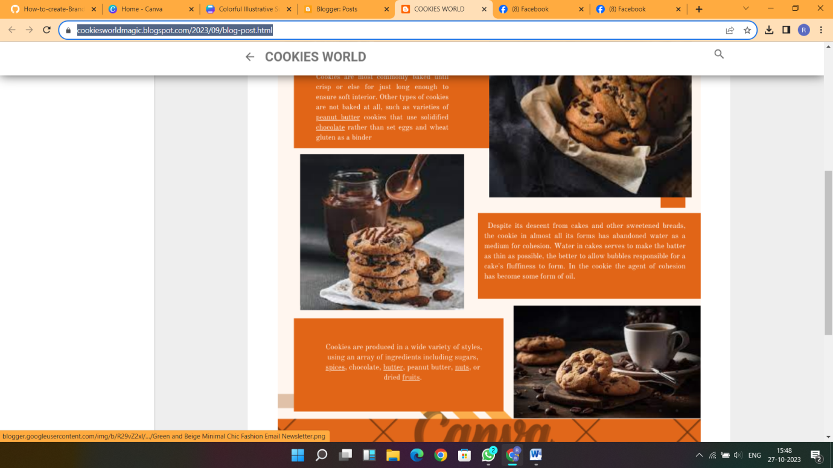

INFOGRAPHIC :

<https://placetovisitoncealife.blogspot.com/2023/09/blog-post.html>

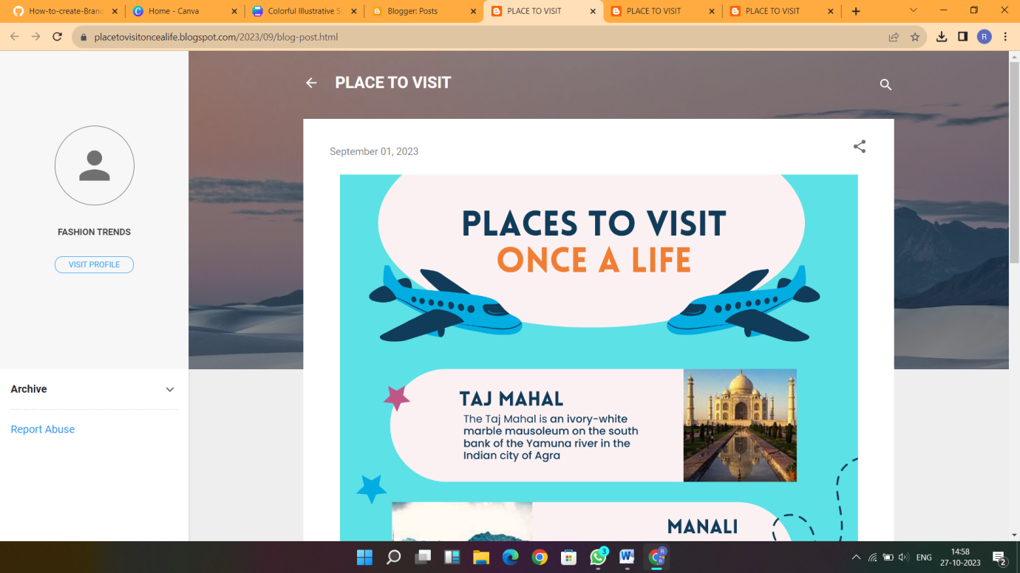

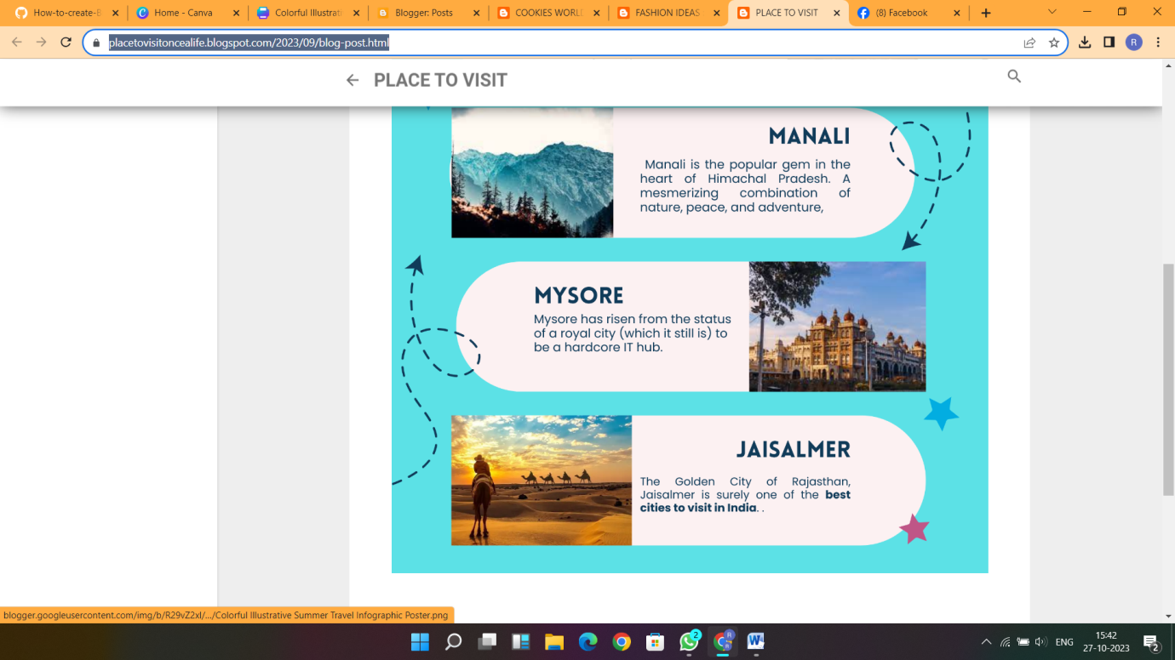

DEMO VIDEO LINK :

<https://drive.google.com/file/d/1F8Scm-TSYJf63EOnzMmiTZXPjt8p_KBK/view?usp=drivesdk>